CURSOR PACKAGE:

CREATE OR REPLACE PACKAGE emp_cursor_pkg IS

CURSOR emp_cursor IS

SELECT empid,lastname,salary FROM employees;

PROCEDURE display_employees;

END emp_cursor_pkg;

/

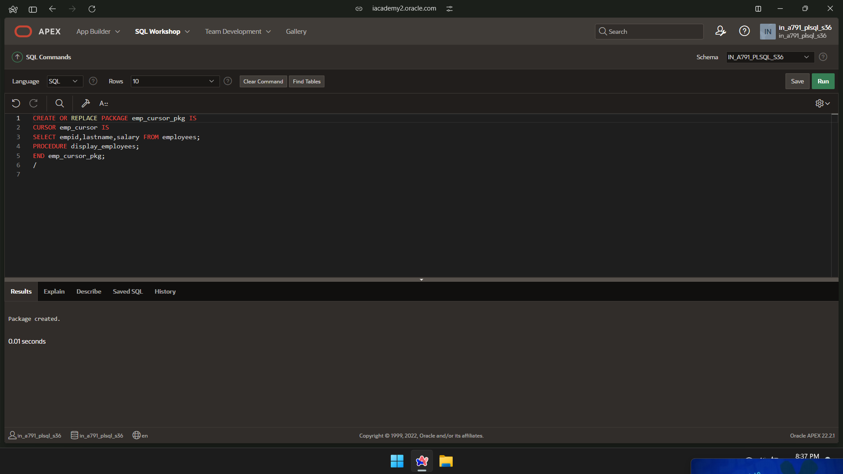

PACKAGE CURSOR BODY:

CREATE OR REPLACE PACKAGE BODY emp_cursor_pkg IS

PROCEDURE display_employees IS

emp_record emp_cursor%ROWTYPE;

BEGIN

OPEN emp_cursor;

LOOP

FETCH emp_cursor INTO emp_record;

EXIT WHEN emp_cursor%NOTFOUND;

DBMS_OUTPUT.PUT_LINE('Employee ID: ' || emp_record.empid ||', Last Name: ' || emp_record.lastname ||', Salary: ' || emp_record.salary);

END LOOP;

CLOSE emp_cursor;

END display_employees;

END emp_cursor_pkg;

/

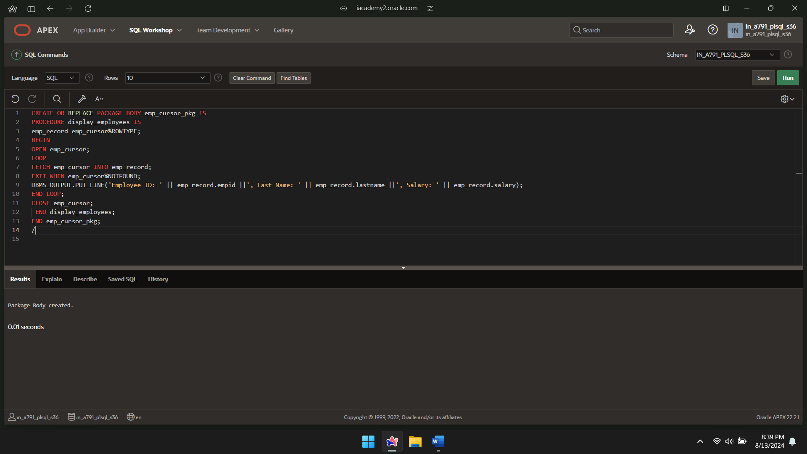

CURSOR PACKAGE INVOKE:

BEGIN

emp_cursor_pkg.display_employees;

END;

/

